**Lab05 Documentation:**

**Lab Assignment:**

1. Demonstrate Unix exercise 2 and 4.

**Exercise 2. Execute process in the background.**

*Terminal output:*

C:\Users\Vishnu Rana>bash

root@vishnu-rana:/mnt/c/Users/Vishnu Rana# ssh 32879349@ceto.murdoch.edu.au

32879349@ceto.murdoch.edu.au's password:

Last login: Tue Sep 10 10:08:10 2019 from 134.115.199.192

32879349@ceto:~$ ***sleep 30 &***

[1] 30869

32879349@ceto:~$ ps -el | grep http

32879349@ceto:~$ ps

PID TTY TIME CMD

30856 pts/0 00:00:00 bash

30869 pts/0 00:00:00 sleep

30893 pts/0 00:00:00 ps

32879349@ceto:~$ ps -el

F S UID PID PPID C PRI NI ADDR SZ WCHAN TTY TIME CMD

4 S 0 1 0 0 80 0 - 9146 - ? 00:02:45 systemd

1 S 0 2 0 0 80 0 - 0 - ? 00:00:00 kthreadd

1 I 0 3 2 0 60 -20 - 0 - ? 00:00:00 rcu_gp

1 I 0 4 2 0 60 -20 - 0 - ? 00:00:00 rcu_par_gp

1 I 0 6 2 0 60 -20 - 0 - ? 00:00:00 kworker/0:0H-kblockd

1 I 0 8 2 0 60 -20 - 0 - ? 00:00:00 mm_percpu_wq

5 S 32879349 30855 30853 0 80 0 - 5493 - ? 00:00:00 sshd

0 S 32879349 30856 30855 0 80 0 - 2185 do_wai pts/0 00:00:00 bash

0 S 32879349 30869 30856 0 80 0 - 1553 hrtime pts/0 00:00:00 sleep

4 S 0 30884 787 0 80 0 - 4874 - ? 00:00:00 sshd

5 S 107 30885 30884 0 80 0 - 3038 - ? 00:00:00 sshd

0 R 32879349 30894 30856 0 80 0 - 2304 - pts/0 00:00:00 ps

32879349@ceto:~$ ls

group-project myHome public_html

***[1]+ Done sleep 30***

**4. Display the information about filesystem:**

root@vishnu-rana:/mnt/c/Users/Vishnu Rana# bash

root@vishnu-rana:/mnt/c/Users/Vishnu Rana# df

Filesystem 1K-blocks Used Available Use% Mounted on

rootfs 222536700 207245240 15291460 94% /

none 222536700 207245240 15291460 94% /dev

none 222536700 207245240 15291460 94% /run

none 222536700 207245240 15291460 94% /run/lock

none 222536700 207245240 15291460 94% /run/shm

none 222536700 207245240 15291460 94% /run/user

cgroup 222536700 207245240 15291460 94% /sys/fs/cgroup

C:\ 222536700 207245240 15291460 94% /mnt/c

D:\ 26214396 1462820 24751576 6% /mnt/d

root@vishnu-rana:/mnt/c/Users/Vishnu Rana#

*Filesystem is created on a disk partition, the device name is rootf.*

*The other disk filesystem is created on a disk partition whose name is cgroup and is mounted on directory /mnt/d. The root filesystem is 94% used and the other is 6% used.*

1. Complete C program Exercise 3.

Change the structure of the program to read the input and return an output.

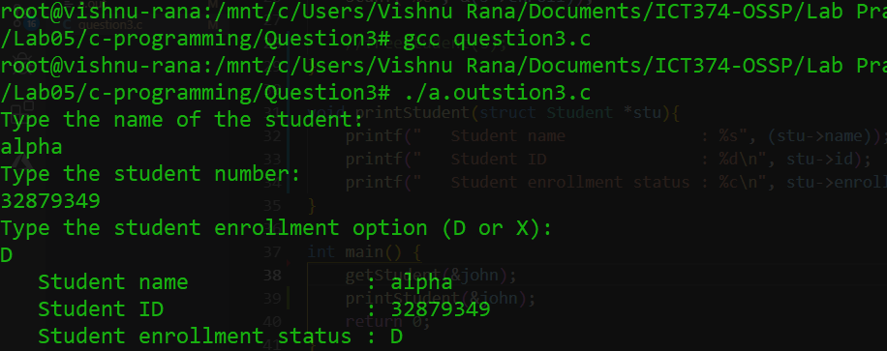

1. Complete Unix programming Exercise 5.

**Get the exit status of child process:**

